## **CONVERTING BAD UI TO A GOOD UI DESIGN**

To convert a bad UI design into a good one, focus on improving visual hierarchy, readability, and spacing. Use clear typography, proper contrast, and well-aligned elements to enhance clarity. Ensure intuitive navigation with labeled icons and interactive feedback. Secure sensitive information by masking it and providing a "Show/Hide" option. A clean, user-friendly design improves both aesthetics and functionality, making the interface more accessible and efficient.

## **BAD DESIGN:**

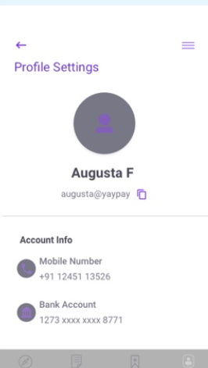

Why this is a bad design?

### **1. Poor Visual Hierarchy**

* The most critical information (such as the email, phone number, and bank account) lacks emphasis.

### **2. Inconsistent and Poor Contrast**

* The text color is light gray and purple, which makes it hard to read against a white background.

### **3. Confusing Icons and Navigation**

* The hamburger menu icon in the top right does not indicate what options it contains.

# **GOOD DESIGN:**

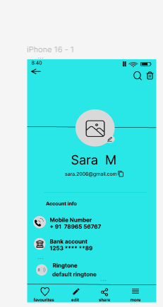

How this is good design:

### **1. Improved Visual Hierarchy**

The user's name and email are well-positioned and easily readable.  
 Icons and text are aligned properly for better clarity.

### **2. Better Contrast and Readability**

The black text on a bright blue background provides better readability than the earlier light gray text.  
Icons are bold and distinguishable, improving accessibility.

### **3. Clear Navigation and Interaction**

The bottom navigation bar is **well-labeled** ("favourites," "edit," "share," "more"), making it easier to understand.  
 The **search** and **delete** icons in the top right are clearly visible and functional.

### **4. Security Improvements**

The **bank account number is masked** (only the last two digits are visible), reducing security risks.

### **5. Additional Features**

A "Ringtone" section is added, showing customization options.  
 The **clipboard icon** next to the email suggests copy functionality, improving usability.

### **Overall Comparison**

\***New Design:** Cleaner, more readable, well-organized, and user-friendly.  
* **Old Design:** Poor contrast, cluttered alignment, weak navigation, and security risks.

## **Conclusion:**

The new UI design is a significant improvement over the previous one, offering better readability, organization, and user experience. It enhances visual hierarchy, ensures proper spacing, and provides clear navigation. The improved contrast and masked sensitive information make it more secure and accessible. Overall, this refined design creates a more intuitive and user-friendly interface, enhancing both functionality and aesthetics.